1. Created s3 bucket where added Netflix raw data csv and configured

Created table on fly in AWS Glue

Athena result

\*\*\*\*Now Automatic with lambda function \*\*\*\*\*\*

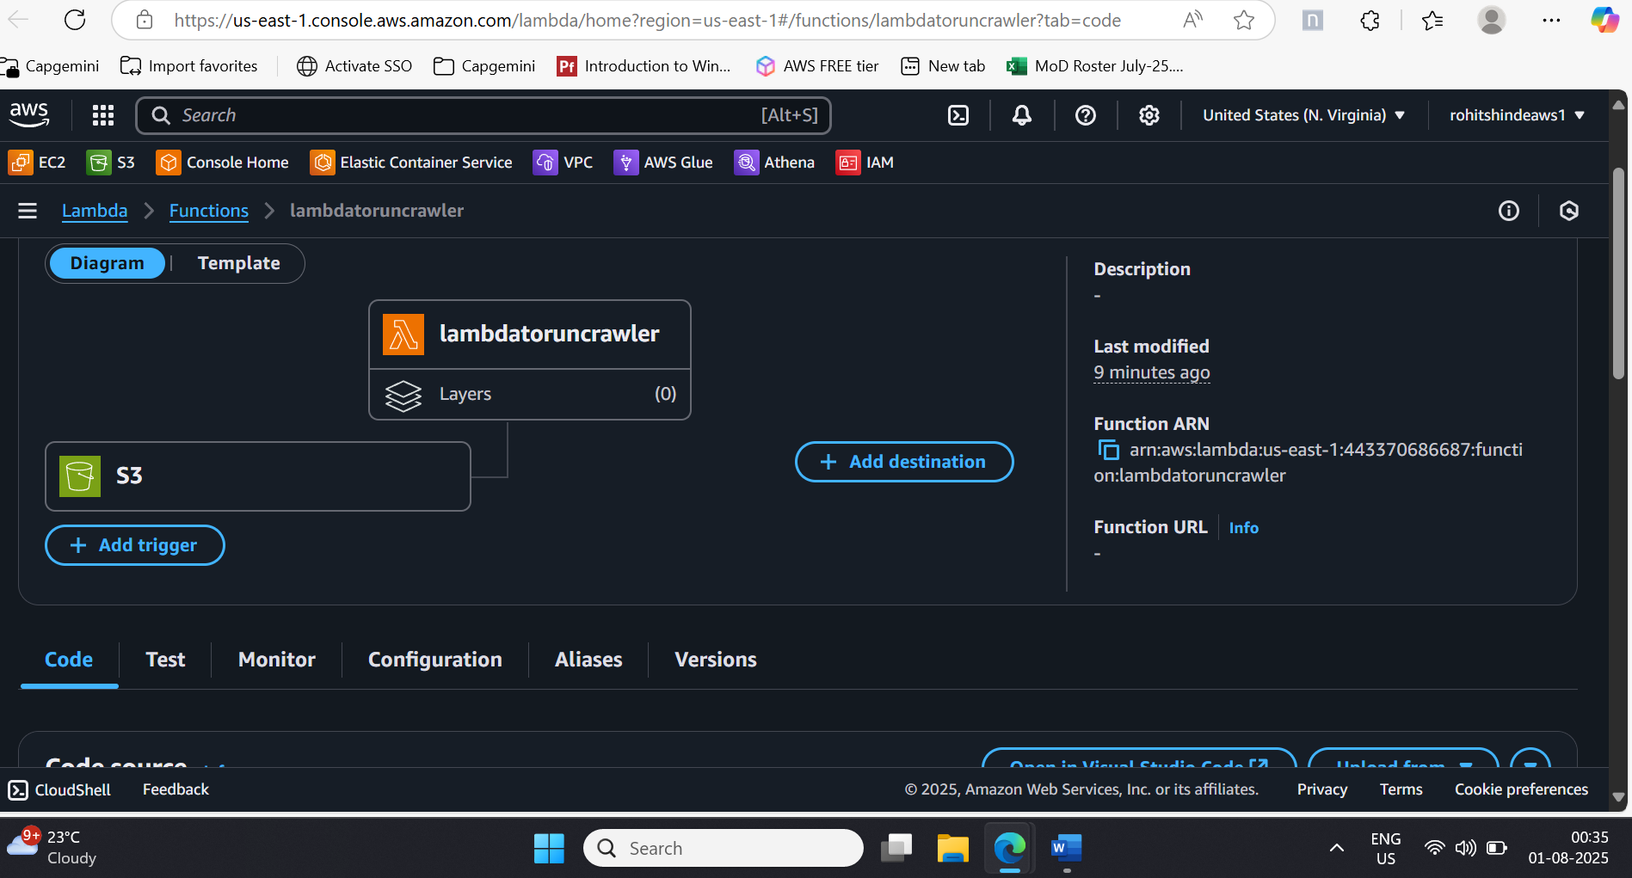

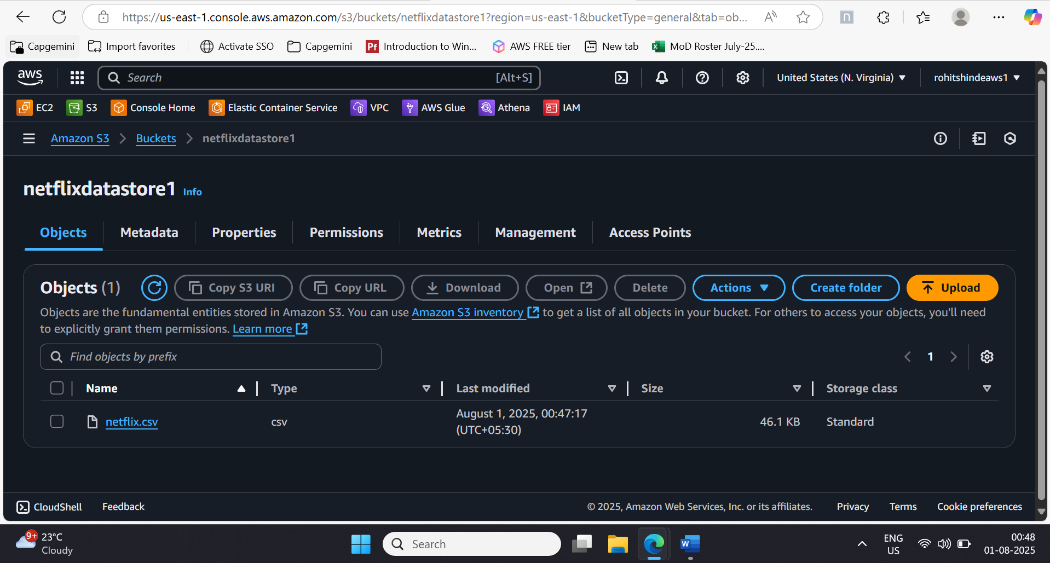

Lambda got called

